NAME: K Yamini
REG NO: 192572181

Write a Prolog program to implement Monkey Banana Problem.
Aim:
To implement the Monkey Banana Problem in Prolog using facts and rules, where the monkey finds a way to reach the banana.
Algorithm:
- Start the program.
- Define the initial position of the monkey.
- Define the position of the box.
- Define the position of the banana.
- Check whether the monkey and banana are at the same position.
- If the monkey is at the box position, the monkey can climb the box.
- If the monkey is not at the box position, move the monkey to the box.
- Push the box to the banana position.
- Climb the box.
- Take the banana.
- Display all actions.
- Stop the program.
Prolog program:
% EXPERIMENT 25
% Monkey Banana Problem

% Initial state:
% Monkey is at door
% Box is at window
% Banana is at middle

% Move monkey from one place to another
move(monkey, From, To) :-
write('Monkey moves from '),
write(From),
write(' to '),
write(To),
nl.

% Push box from one place to another
push_box(From, To) :-
write('Monkey pushes box from '),
write(From),
write(' to '),
write(To),
nl.

% Climb the box
climb :-
write('Monkey climbs onto the box'),
nl.

% Take banana
take_banana :-
write('Monkey takes the banana'),
nl.

% Main solution
monkey_banana :-
write('Initial State:'), nl,
write('Monkey = door, Box = window, Banana = middle'), nl, nl,

move(monkey, door, window),
push_box(window, middle),
climb,
take_banana,

nl,
write('Goal achieved: Monkey gets the banana.'),
nl.
Input:
?- monkey_banana.

Output :
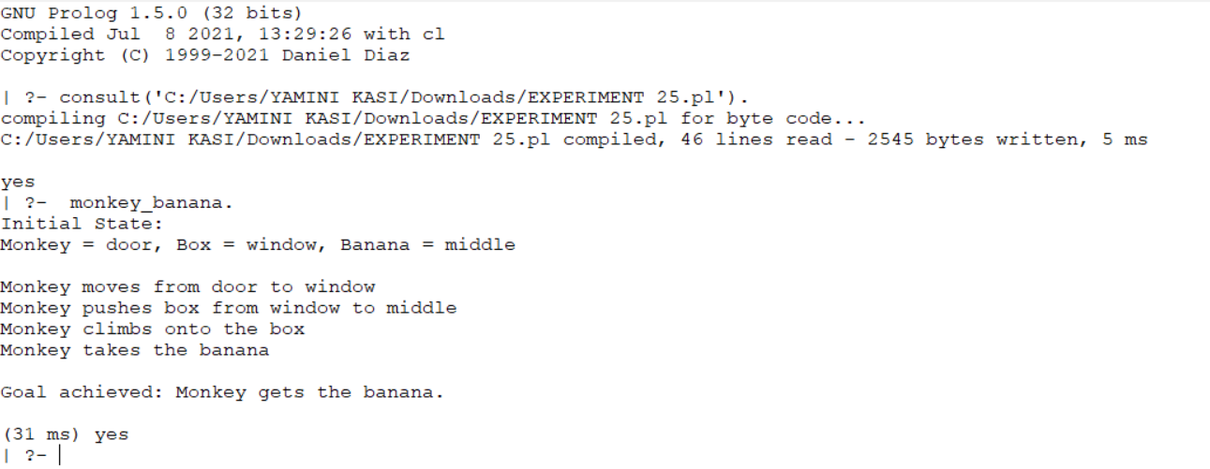
Result:
Thus, the Monkey Banana Problem was successfully implemented in Prolog, and the monkey successfully reaches and obtains the banana.

